WEATHER CLIMATE WATER |   World Meteorological Organization  COMMISSION FOR WEATHER, CLIMATE, WATER AND RELATED ENVIRONMENTAL SERVICES AND APPLICATIONS  Second Session  17 to 21 October 2022, Geneva | SERCOM-2/Doc. 5.5(2)
Submitted by:
Chair
18.X.2022
APPROVED
[The amendments in section 2.8 in the document have been made by Israel]
AGENDA ITEM 5: TECHNICAL REGULATIONS AND OTHER TECHNICAL MATTERS
AGENDA ITEM 5.5: Climate services

ModerniZation of the WMO State of the Climate monitoring

DRAFT DECISION

Draft Decision 5.5(2)/1 (SERCOM-2)

Modernization of the WMO State of the Climate monitoring
The Commission for Weather, Climate, Water and Related Environmental Services and Applications decides:
(1) To request the Standing Committee on Climate Services (SC-CLI) to actively promote the importance of the correct application of the Climatological Standard Normals and baselines in communicating information on climate change and variability. This would contribute to the modernization of the WMO State of the Climate monitoring activities at global, regional and national levels;
(2) To endorse the guidance on baselines proposed by the SC-CLI as provided in the annex;
(3) To request the SC-CLI to collaborate with other relevant Standing Committees of the Commission, the Research Board, the Commission for Observation, Infrastructure and Information Systems (INFCOM) and the Regional Associations on the use and value of this guidance by Members in various applications and report back the Commission at the next session;
(4) To request the Secretary-General to facilitate the publication of this guidance as formal reference.
See the annex to the present decision.
_______
Decision justification: The outcomes of the Standing Committee of Climate Services (5-7 April 2022) and then the second meeting of the WMO Technical Coordination Committee (26-27 April 2022), on the need for guidance on the use of Climatological Standard Normals and other baselines.

Annex to draft Decision 5.5(2)/1 (SERCOM-2)

GUIDANCE ON THE USE OF CLIMATOLOGICAL STANDARD NORMALS AND OTHER BASELINES IN MONITORING THE STATE OF THE CLIMATE

1. Introduction
1.1 From discussions at the Fourth meeting of the Standing Committee on Climate Services (SC-CLI-4, 5–7 April 2022) and the second meeting of the WMO Technical Coordination Committee (26–27 April 2022), it became apparent that the interpretation of the Climatological Standard Normals (CLINO) in various applications, was not as clear as was hoped, and consequently there has been a request for better guidance on the role of modern CLINO and other baselines in both supporting general climate service provision as well as monitoring climate change.
1.2 To respond to this request, the special meeting on baselines and reference periods was organized on 12 May 2022 involving subject matter experts from data requirements perspective and climate monitoring perspective. There, the current relevant regulations including Resolution 16 (Cg-17) - Report of the sixteenth session of the Commission for Climatology, in 2015 and results from the survey of WMO Member’s practices on baselines were presented. Upon this background, the discussion paper on baselines submitted to SC-CLI-4 (agenda item 3.3.2 of SC-CLI-4) was introduced and participants exchanged their views and practices about baselines (meeting summary).
1.3 WMO technical regulations include the use of a dual-normal approach. Firstly, the use of the most recent 30-year period ending in a ‘0’ year (currently, 1991–2020) for most applications. Secondly, the long-term use of 1961–1990 for specific purpose of long-term climate change monitoring to ensure a stable reference period. (Manual on the High-quality Global Data Management Framework for Climate (WMO-No. 1238))

1.4 The period 1961–1990 provides a solid and stable baseline for monitoring basic climatic variables using surface based observing networks that operated since 1961 or earlier, although it cannot be used as a baseline for data and products derived from satellite observations which go back only as early as 1979, which form an increasingly important part of the climate record.

2. Examples of existing practices
2.1 Recently, for global mean temperature analysis, the most important baseline among various baselines is 1850–1900 which is used in lieu of a true “pre-industrial” baseline (IPCC AR6, IPCC SR15), as mentioned in the text of the Paris Agreement. While the 1850–1900 baseline is important for global mean temperature, low data density prior to 1900 makes it an unrealistic baseline to use at national or regional scales in most parts of the world, or for most variables other than temperature. Improving data coverage of the pre-industrial period through data rescue would help making comparison of national temperature assessment with the global one based on the same reference period.
2.2 For example, in the WMO State of the Global Climate in 2021, the period of 1850–1900 is used as a baseline period to show changes in the global annual mean temperature.

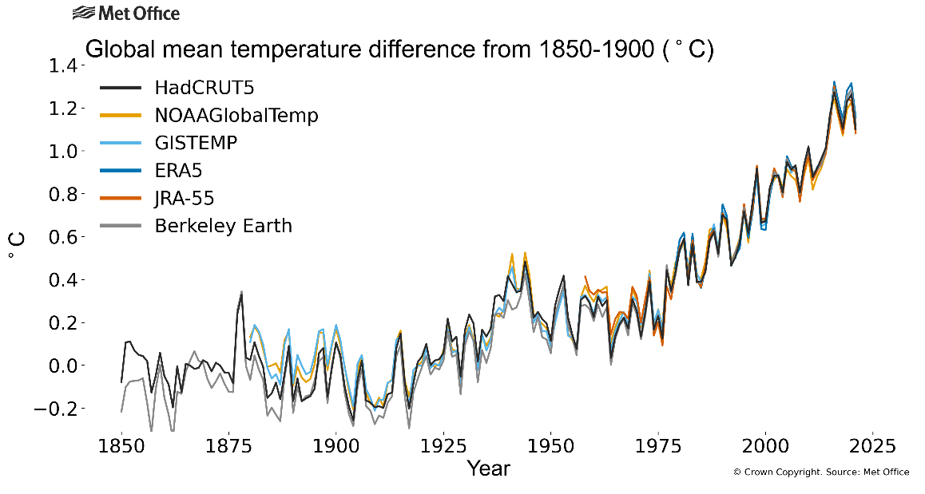
Figure 1: Global annual mean temperature difference from pre-industrial conditions (1850–1900) for six global temperature data sets 1850–2021. The anomalies were calculated by using the method from the IPCC Sixth Assessment Report Working Group I, based on the estimated amount 0.69°C of difference between 1850–1900 and 1981–2010

Source: WMO State of the Global Climate 2021.
2.3 In addition, the period of 1981–2010 is also used to show spatial distribution of annual mean temperature in 2021, or time series of sea-ice extent due to above-mentioned limitation of datasets or observation network.
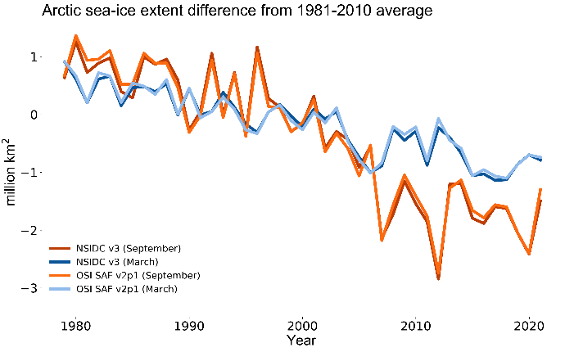
Figure 2: Sea-ice extent difference from the 1981–2010 average in the Arctic for the months with maximum ice cover (March) and
minimum ice cover (September) from 1979 to 2021.
Source: WMO State of the Global Climate 2021.
2.4 At the national level, National Climate Monitoring Products (NCMPs) specifically summarize climatic conditions at a national scale and show how current conditions compare with those in the past. For NCMPs to be comparable among countries, it is essential to have a consistent base period and the standard climatological normal is adopted for the calculation of NCMPs. Similarly, real-time forecast anomalies are customarily defined with respect to a standard base period. This allows context for real-time seasonal prediction anomalies to be set relative to a “climate normal” over a selected period.
2.5 On the other hand, inference of climate change information requires additional analyses of trends, extremes and record values put in a longer historical perspective. It should be noted that important metrics, such as changes in a variable, trends and rankings are generally insensitive to the choice of baseline.
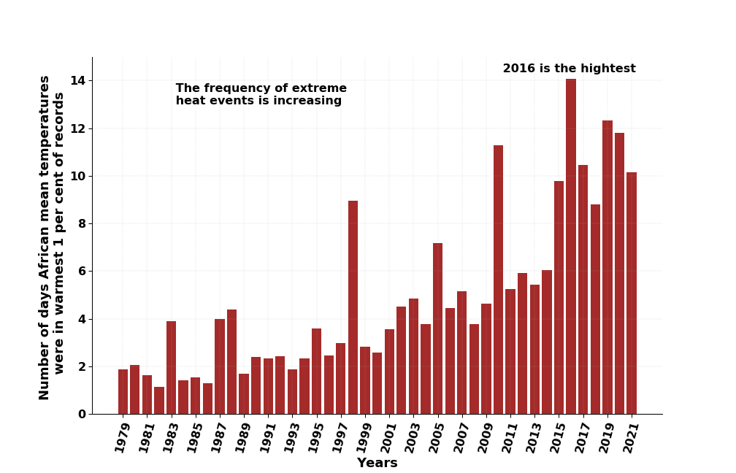
Figure 3. Annual number of extreme warm days in Africa from 1979 to 2021 derived by African Centre of Meteorological Application for Development (ACMAD), based on COPERNICUS datasets, ERA5 reanalysis.
Source: WMO State of the Climate in Africa 2021
2.6 Using a historical fixed benchmark is highly recommended when communicating long-term climate change, so that the magnitude of ongoing changes does not appear to “reset” every 10 years. Concerns have been raised that using the most recent baseline could cause difficulties in communicating the status of change in particular for temperature, each time the baseline is updated.
2.7 In this regards the use of 1961–1990 as a baseline for evaluating long-term temperature change, in addition to the changes estimated using 1981–2010 period, has been tested successfully in the most recent Regional State of the Climate reports (in these reports the most recent climatological normal is 1981–2010 while waiting the update to 1991–2020). For example, WMO State of the Climate in Africa 2021 says that “For Africa, the near-surface air temperature in 2021 was between 0.55 °C and 1.04 °C (a mean anomaly of 0.71 °C) above the 1981–2010 average. In addition, the near-surface temperature was between 1.03 °C and 1.23 °C (a mean anomaly of 1.12 °C) above the 1961–1990 average”. By comparing the anomalies against two baselines, it becomes clear that the mean state of climate has been warming. At the same time, this also shows importance of keeping a fixed baseline for evaluating long-term temperature change in the changing climate.

2.8 Percentile-base indices (e.g., Warm days, Cold nights, Warm/Cold Spell Duration Index) have been widely used in scientific publications including those of the IPCC. When applying percentile-based temperature indices the selected baseline can be crucial. Here, unlike with fixed threshold indices, when selecting 1961–1990 or 1981–2010 (and even more prominently in 1991–2020) as a base-period, the calculated linear trends will be dramatically different (for both long and short-term), especially in a continuously changing climate that is expected to get much warmer in coming years according to global and regional climate models,.

3. Recommendations
3.1 The recommendations (1) to (7) below address the various usage of existing reference periods as baselines. Temperature is the most prominent indicator for tracking climate change and related extremes. It is therefore the parameter that can benefit the most from this guidance to improve climate monitoring and climate change information, and its communication. The guidance can also apply to other parameters, once sufficient data are available.
(1) Use CLINO, updated every 10 years for all climate applications. This would provide a single approach for all climate information and allow a much wider range of data to be used consistently. In particular for operational climate monitoring and seasonal forecasting, NMHS are encouraged to make use of existing guidance such as the WMO Guidelines on Generating a Defined Set of National Climate Monitoring Products (WMO-No. 1204), and the WMO Guidance on Operational Practices for Objective Seasonal Forecasting (WMO-No. 1246)
(2) Climate indicators should be calculated, to the extent possible, using the most recent CLINO period to compute anomalies. These anomalies should be accompanied by a more in-depth analysis of trends and extremes to properly reflect the long-term changes. See figures 1 and 2 above from the WMO State of Global Climate 2021 report for example.
(3) In addition, it is highly recommended to use a fixed historical benchmark for long-term climate change monitoring, so that the magnitude of ongoing changes does not appear to “reset” every ten years. For this purpose, it is recommended to use the WMO Reference Period (the consecutive period of 30 years from 1 January 1961 to 31 December 1990) as a complement for climate information based on the most recent Climate Standard Normals. See an example from WMO State of the Climate in Africa 2021 in Section 2 above.
(4) Use 1850–1900 period as a common approach for tracking global mean temperature. This is particularly useful for estimating global temperature change in the context of United Nations Framework Convention on Climate Change (UNFCCC) Paris agreement. However, this baseline might not be applicable currently on limited domains such as national scale as explained in Section 2.
(5) Always specify explicitly the reference period used. Adequate historical and geographical context should be provided for the user of the information to understand the significance of the information that is being presented.
(6) When baselines are updated, previously calculated normals should be retained. Averages (and other statistics) for older periods can be useful to understand how old reports relate to newer reports, and also to track changes in the climate.
(7) Adjustments in baselines and the resulting implications should be communicated to users when changes are made. Ideally, this communication effort should be implemented prior to the transition to the new baselines, so that users are prepared for properly interpreting the climate information, based on the new updated baselines.
(8) The period 1961–1990 as a baseline for evaluating long-term temperature change should be taken into special consideration when analysing percentile-based extreme temperature indices, since it may possibly be less relevant in about a couple of decades for monitoring changes in such extremes (the rate of exceedance will be very high/low in the future).
___________________

There is a paper (currently in review) on using pre-industrial period in Australia using the limited historical observations along with models.
WMO Guidelines on Generating a Defined Set of National Climate Monitoring Products (WMO-No. 1204)
Guidance on Operational Practices for Objective Seasonal Forecasting (WMO-No. 1246)
Yosef, Y., Aguilar, E., & Alpert, P. (2021). Is it possible to fit extreme climate change indices together seamlessly in the era of accelerated warming?. International Journal of Climatology, 41, E952-E963.‏ https://doi.org/10.1002/joc.6740
Dunn, R. J., & Morice, C. P. (2022). On the effect of reference periods on trends in percentile-based extreme temperature indices. Environmental Research Letters, 17(3), 034026.‏
Headline Indicators for Global Climate Monitoring, Trewin et al. Bulletin of the American Meteorological Society Volume 102 Issue 1 (2021) (ametsoc.org)

